Paper Review of Cheng by 06/23/2020

* Title: Construction of Feature Landmark Database Using Omnidirectional Videos and GPS Positions
* Needs
  + Many tags and beacons will be updated or installed, but it is not convenient to record.
  + For large building complexes, manually creating 3D models to record landmark is too time-consuming and laborious
  + Locating landmarks using SfM and GPS has many errors that influence the accuracy of results.
* Objectives
  + A more applicable camera system.
  + Detect and create 3D model without manual measurement
  + A database that can store and update information in real time.
  + An algorithm that can correct and reduce position information errors
* Methodology
  + Authors propose an automatically-measuring database system to keep landmark information.
  + The images are captured by omnidirectional multi-camera system (OMS), and the location coordinates are from GPS positions which adjusted by SfM algorithm.
  + The authors devised a coordinate estimation method to optimize the position of the actual signs, making them more accurate.

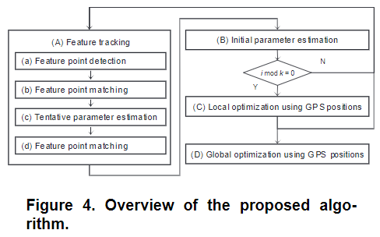

* Results

The experiment records 100 frames video at 6 positions per frame, and the first and last two frames are 1.5 kilometers away. It was found that except for the location estimation error of several locations exceeding 10 meters, the rest were in line with expectations. In addition, the speed of integrating the video information to obtain the 3D model is also very fast, and the position data can be stored in the database in real time

* Discussion
  + Maybe the designed method and database can be used for augmented reality system.
* Conclusion
  + This article describes a system that automatically constructs a landmark database, using omnidirectional video and GPS positioning methods
  + This system can quickly detect and estimate the position information of landmarks accurately, without human to measure.